University of Wolverhampton
School of Mathematics and Computer Science
5CS022 Distribute and Cloud Systems Programming
Workshop 3 The Akka Framework
Overview
This workshop continues the exploration of the Akka Framework from the previous tutorial.
1. The Actor class Actors in the sample Akka program currently responds to only one message object – MessageA. Modify the createReceive() method so that it will also respond to any other message and print out the message on the standard output.

Program:
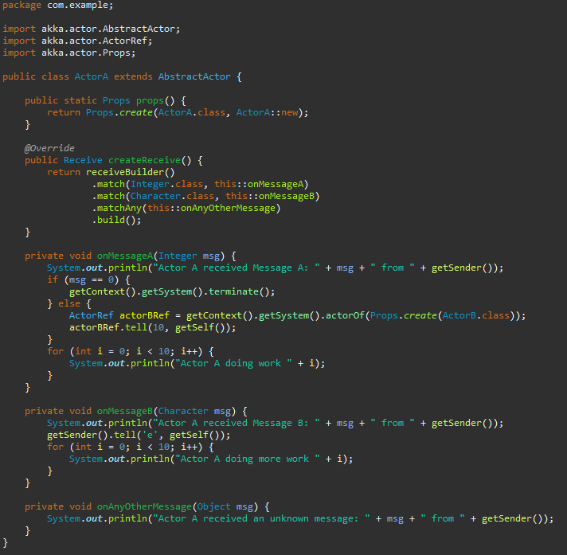
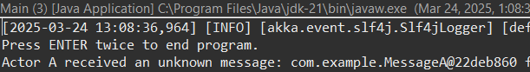
Explanation: This Akka actor, ActorA, is designed to handle three types of messages. If it receives an Integer, it processes the message in the onMessageA method, where it prints the message and, if the value is 0, terminates the actor system. Otherwise, it creates a new actor (ActorB) and sends it a message. If ActorA receives a Character, it processes it in onMessageB, prints the message, responds with 'e', and performs additional work. For any other message type, the onAnyOtherMessage method logs the received message, ensuring the actor handles unexpected inputs gracefully.
2. Every message in Akka is a Java object. However, not all messages need to have a custom Java class created for them. Convert the sample program so that it can respond to messages that contain the primitive data types such as byte, short, int, long, float, double, boolean, and char, without having to create custom Java classes.
Program:
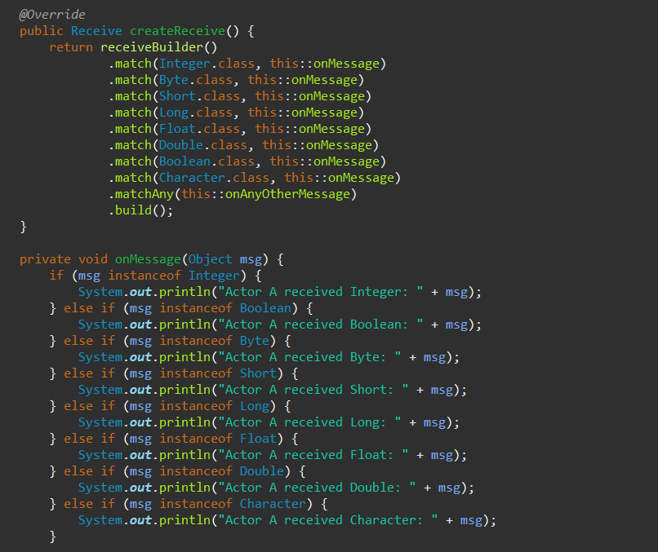

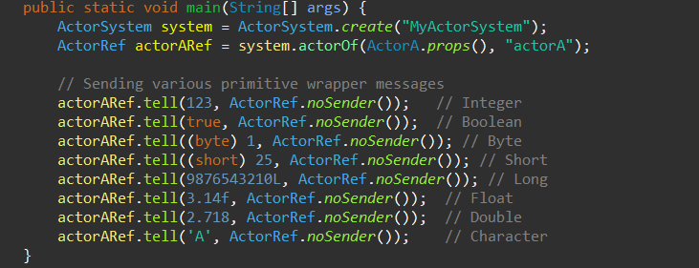

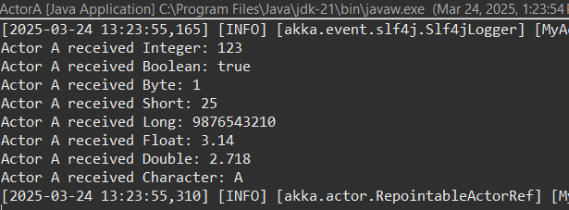

Explanation: This Akka actor program defines ActorA, which can receive and process various primitive wrapper types such as Integer, Boolean, Byte, Short, Long, Float, Double, and Character. The createReceive method specifies handlers for each data type, directing them to the onMessage method. Inside onMessage, the actor identifies the message type, prints it, and performs additional actions such as terminating the system if it receives an Integer value of 0 or forwarding a message to ActorB if it receives another Integer. The main method initializes an actor system and sends test messages of different types to ActorA.
3. Create 2 Akka Actor classes "ActorA" and "ActorB" to demonstrate the Akka API setReceiveTimeout().ActorA will generate a random integer number from 1 to 5 in a loop for 100 times, and send this integer as a message to ActorB, which would then call Thread.sleep() that many seconds. Set the receive timeout to 2 seconds, and when the timeout triggers, send ActorB a stop() message, and then create a new instance of ActorB to process the next number.

Main.java

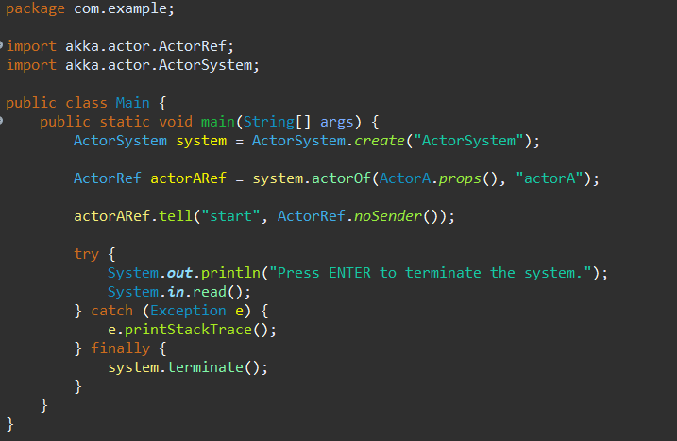

MessageA.java

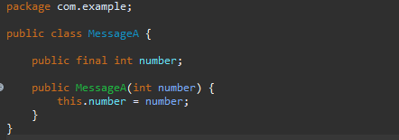
ActorA.java

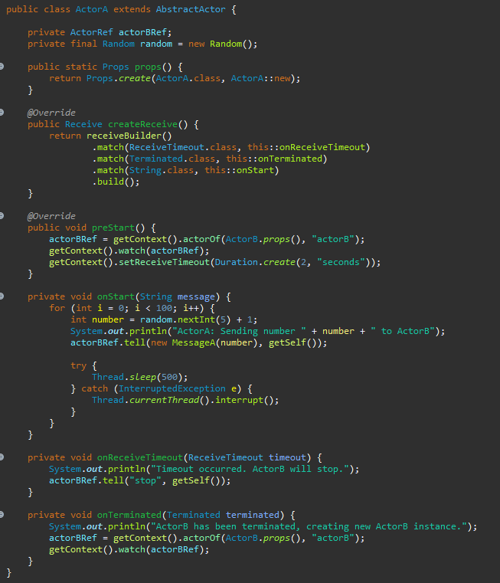

ActorB.java
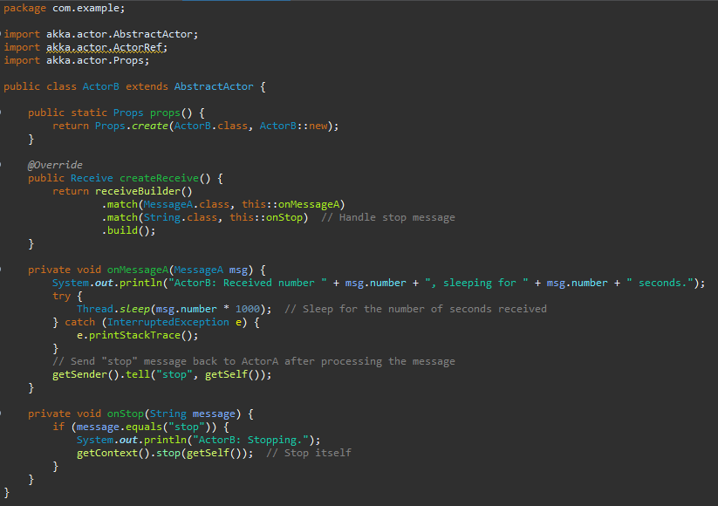
Output:
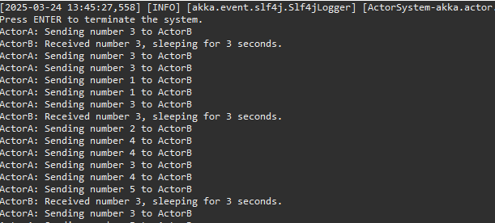

Explanation: In this implementation, ActorA generates random numbers and sends them to ActorB. ActorB processes the numbers by sleeping for the corresponding number of seconds. If ActorA doesn't receive a response within 2 seconds (due to the timeout), it sends a "stop" message to ActorB and creates a new instance of ActorB. The process continues for 100 iterations, and each time ActorB is stopped and replaced with a new instance after the timeout occurs. The output reflects this behavior, showing ActorA sending messages, ActorB sleeping for the specified durations, and new ActorB instances being created after each timeout.

